Kids Menu
From 0 to 12 years old

MAINS + SIDE + DRINK ($16.50)

Ham & Pineapple Cheese Sticks ^{GFO}
SIDES

Chunky Fries
Garden Salad
Mixed Vegetables
Served on Turkish bread

Kids Popcorn Chicken
Deep fried chicken
Grilled Steak ^{GF}
Sirloin steak cooked to your liking
DRINKS

Coke, Lemonade (Raspberry)
Juice (Orange, Apple, Pineapple, Cranberry,)

Kids Pasta ^{V}
Chef choice pasta with parmesan cheese
Mini Burger
Beef patty burger with Swiss cheese

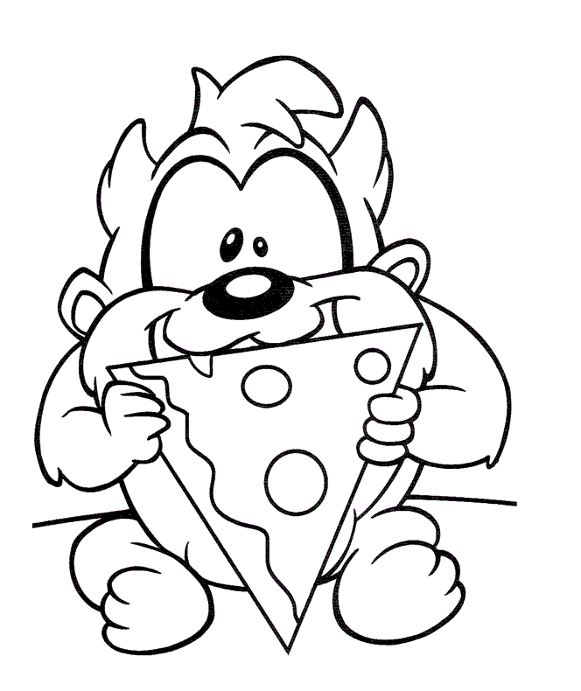
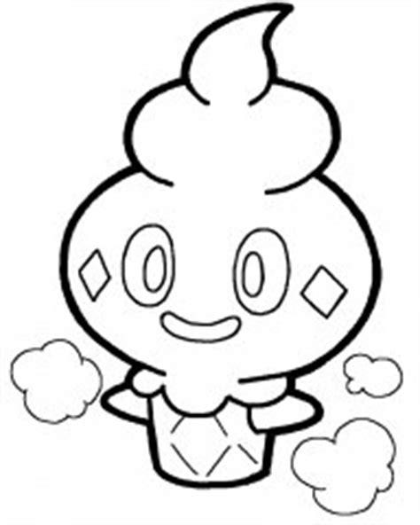
SWEETS ($8.⁵⁰)

Kid’s Sundae
Vanilla ice cream topped with M&Ms
and chocolate sauce

Kid’s Waffle
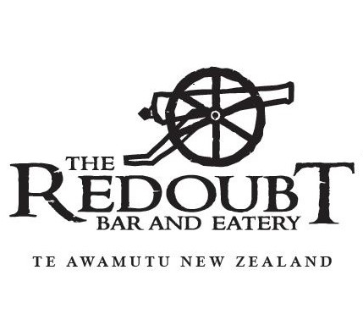
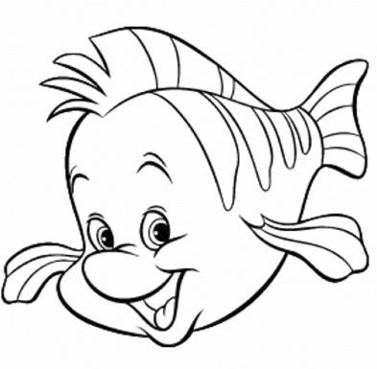
Belgian waffle served with vanilla
ice cream, chocolate sauce and
M & M

